Syntax Directed Translation for Assignment Statements :

In the syntax directed translation, assignment statement is mainly deals with expressions.
The expression can be of type real, integer, array…
Consider the grammar:
S → id := E
E → E1 + E2
E → E1 * E2
E → (E1)
E → id

Non-terminal E has two attributes:
- • E.place, a name that will hold the value of E, and

- • E.code, the sequence of three-address statements evaluating E.

A function gen(…) to produce sequence of three address statements .

The syntax directed translation for assignment statement is given as below;
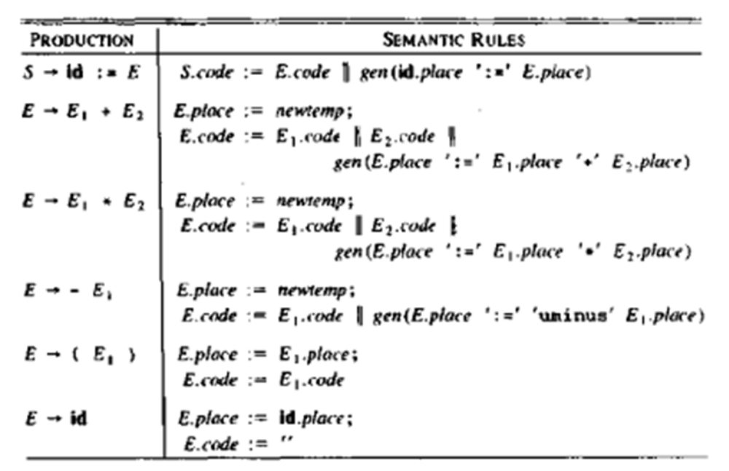

SDT for Boolean Expression:

Boolean expression are composed of the boolean operators(and ,or, and not)

Consider the grammar
E → E or E
E → E and E
E → not E
E → (E)
E → id relop id
E → TRUE E → id
E → FALSE

The relop is any of <,≤,=, ≠, >, or ≥.. We assume that or and and are left associative. or has lowest precedence ,then and ,then not.

Sementic rules for Boolean Expressions:
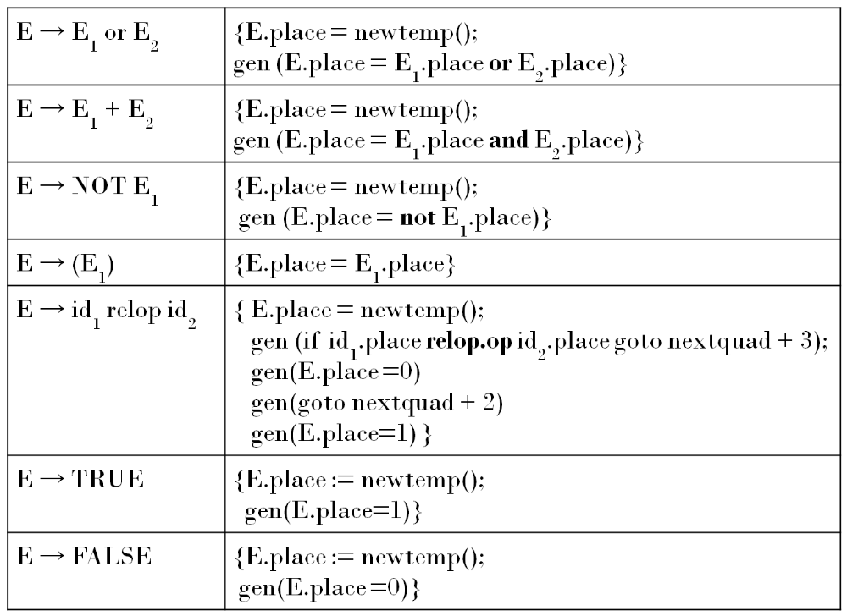

Control Flow Representation:

Short Circuit Evaluation of Boolean Expressions:

Flow of control statements with the jump method.
Consider the following : (short circuit code)

S → if E then S | if E then S1 else S2
S → while E do S1
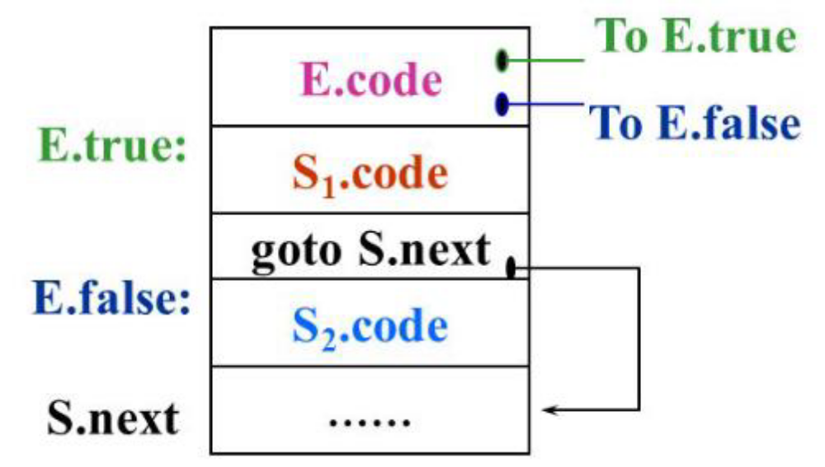

Fig 3.7 Attributes used for if E then S1 else S2

E is associated with two attributes:
1. E.true: label which controls if E is true
2. E.false :label which controls if E is false

S.next - is a label that is attached to the first three address instruction to be executed after the code for S (S1 or S2)

The Semantic rule for flow of control statements is given by:

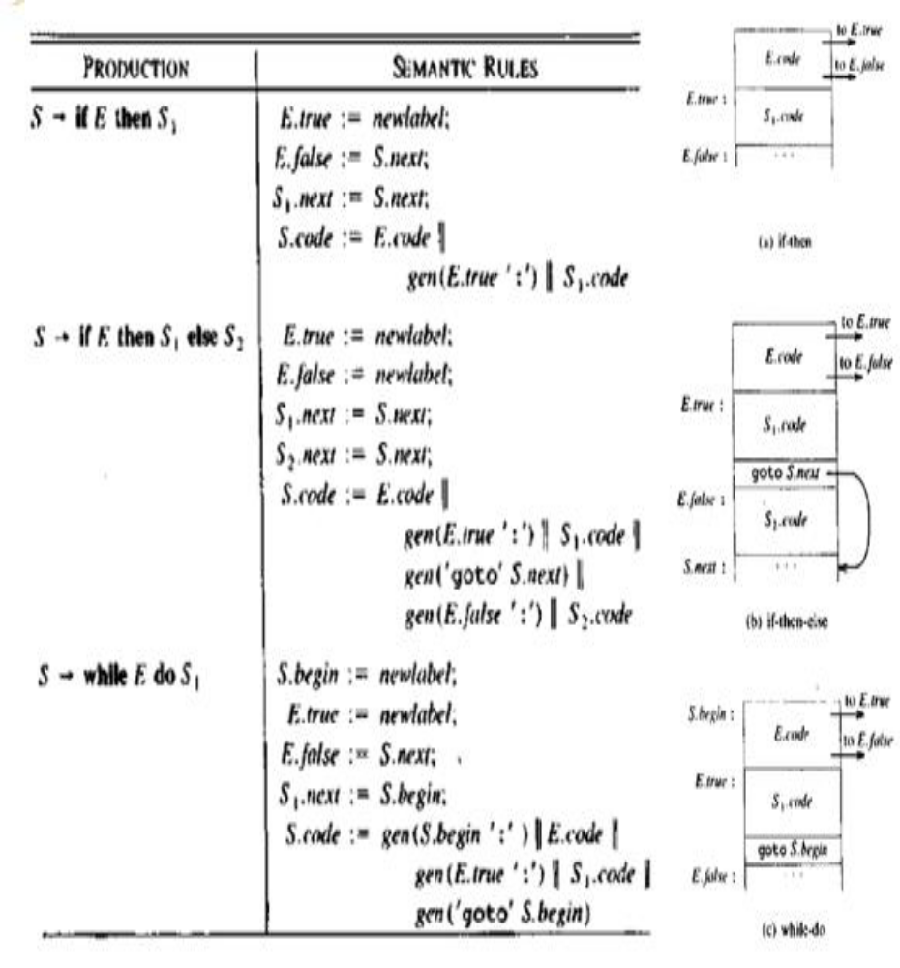

SDT for Switch Case statement:

Switch and case statement is available in a variety of languages. The syntax of case statement is as follows: Syntax for switch case statement

switch E
begin
case V1: S1
case V2: S2
…
case Vn-1: Sn-1
default: Sn
end

When switch keyword is seen then a new temporary t and two new labels test and next are generated. When the case keyword occurs then for each case keyword, a new label Li is created and entered into the symbol table. The value of Vi of each case constant and a pointer to this symbol-table entry are placed on a stack.
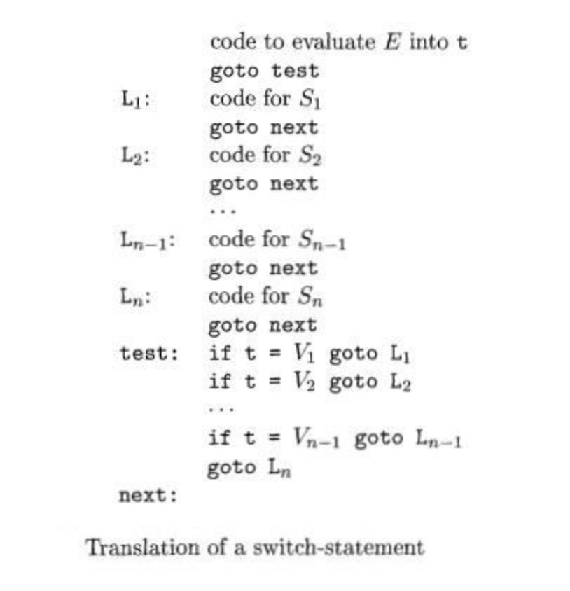
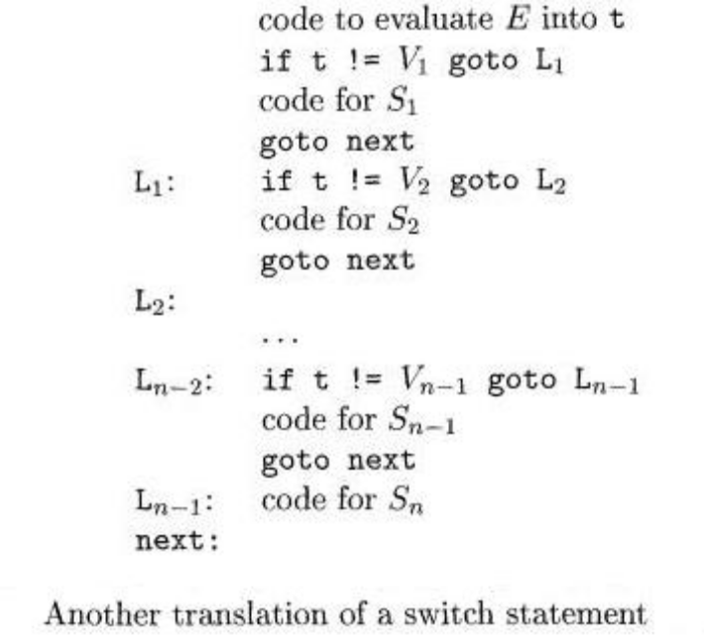

Type Checking

Type checking is the process of verifying and enforcing constraints of types in values. A compiler must check that the source program should follow the syntactic and semantic conventions of the source language and it should also check the type rules of the language.

Types of Type Checking:
There are two kinds of type checking:
- Static Type Checking.
- Dynamic Type Checking.

Static Type Checking: is defined as type checking performed at compile time. It checks the type variables at compile-time.
Examples of Static checks include:
- Type-checks: A compiler should report an error if an operator is applied to an incompatible operand. For example, if an array variable and function variable are added together.

- The flow of control checks: Statements that cause the flow of control to leave a construct must have someplace to which to transfer the flow of control. For example, a break statement in C causes control to leave the smallest enclosing while, for, or switch statement, an error occurs if such an enclosing statement does not exist.

- Uniqueness checks: There are situations in which an object must be defined only once. For example, in Pascal an identifier must be declared uniquely, labels in a case statement must be distinct, and else a statement in a scalar type may not be represented.

- Name-related checks: Sometimes the same name may appear two or more times. For example in Ada, a loop may have a name that appears at the beginning and end of the construct. The compiler must check that the same name is used at both places.

Dynamic Type Checking:
- Dynamic Type Checking is defined as the type checking being done at run time.
- In Dynamic Type Checking, types are associated with values, not variables.
- Dynamic typing is more flexible,

- In dynamically-typed languages like Python, JavaScript, PHP and Perl, type-checking happens at runtime.

